Name: | Kaushik Balaji.M.S
Roll no: | 152502010

CS5107 Programming Lab
Assignment 1

Question:

What if the number of arguments passed to a bash script are more than 9?

Method 1

Mentioning every arguments explicitly with their argument number. To mention arguments from 1-9, we use $1, $2, … $9. Beyond that, we mention the arguments using, ${10}, ${11}, …
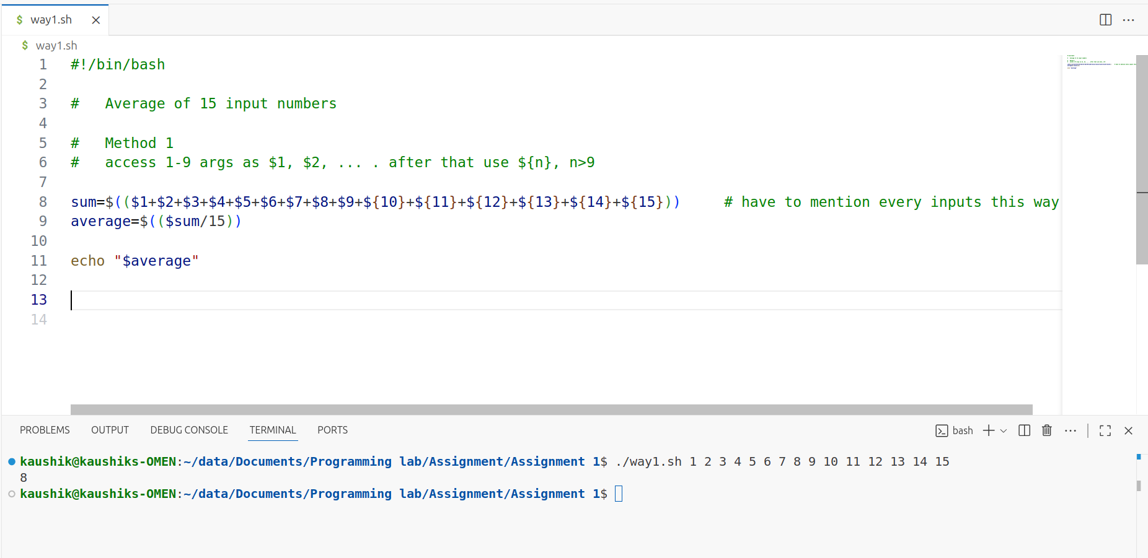
In this, we have to mention every arguments (from 1-9 as $1 … $9 and >10 as ${10} … ).

Method 2
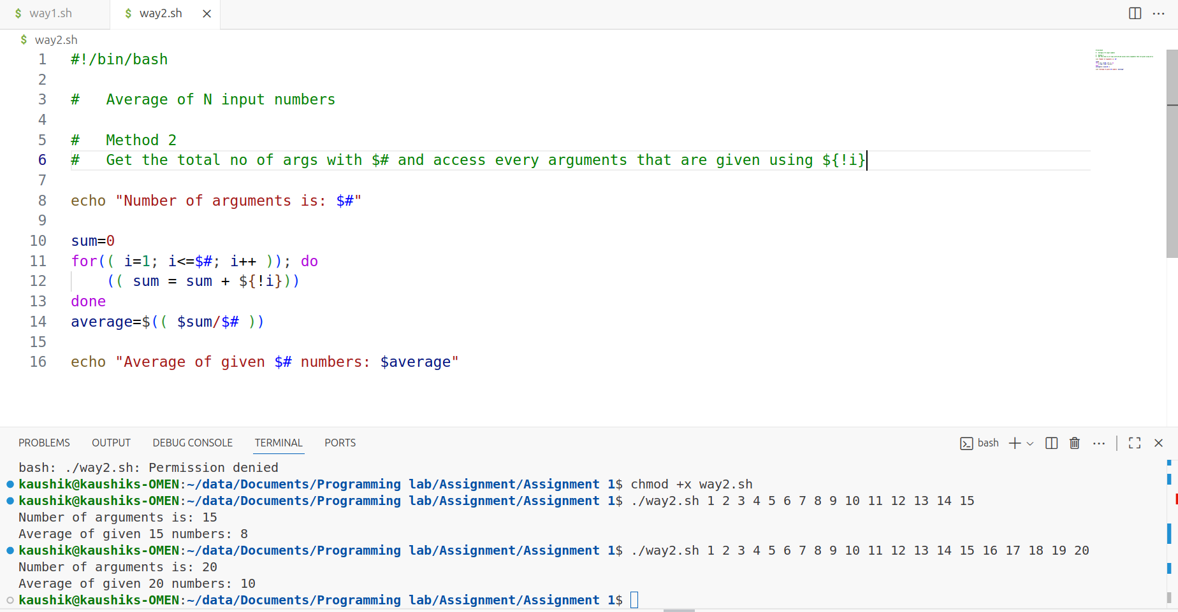
Here, we can get the total number of arguments passed to the bash script using $# which holds the value of no. of argument passed.
Then we can iterate with a loop, and get the individual arguments using ${!i}.
This way even if we don’t know the number of arguments, we can use every arguments mentioned.

Method 3
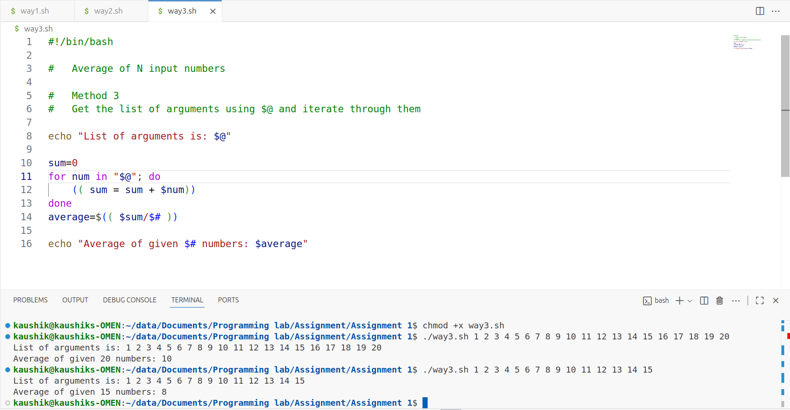
Here, we use $@ to get the list of all arguments given during the execution, and iterate through these arguments in a loop.

